**COLAB 1 – Getting Started with Python**

1. To get started with COLAB sign-in to your Google Account at <http://drive.google.com> (if you don’t have a Gmail account you need to create one).
2. Create a new folder with the name of your choice. In the examples we will assume that this folder is stored in the main directory and called:

“emoryqtm151storage”

1. Go to the folder, right-click to create a new file. Go to more and search “Google Colaboratory”. If it doesn’t show up you may need to select the option at the bottom called “Connect to more apps.”

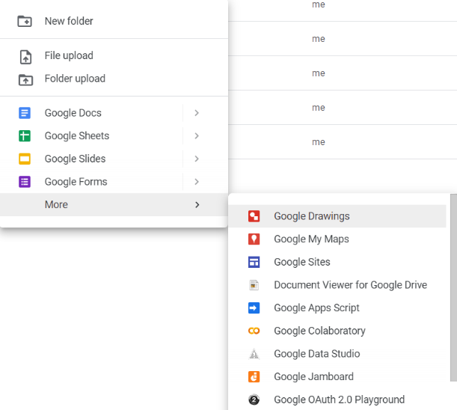

1. Your browser will open a new tab with a new Jupyter notebook! You can start coding.

But wait, you’re not done!! To be able to do more complex tasks you need extra steps! See instructions below.

**Appendix 1: Referencing Files in Google Drive**

The majority of data analysis tasks involve work with datasets or other external files. To store these files in Google Drive and access them from Colab Python you need to add some extra lines of code to **EVERY FILE THAT YOU RUN.**

Upload the following Jupyter Notebook from Canvas, which contains the extra lines of code that you need. Copy-paste them from:

“COLAB 3 - managingfiles_Add-to-Every-Notebook.ipynb”

**NOTE:** You **WON’T** be able to run the lecture notes **UNLESS** you add these lines of code manually. Make sure to change the working directory to the subfolder of each lecture. The lecture notes are designed reference the files in the folder which contains the Jupyter notebook.

**Appendix 2: Synchronizing the Lecture Notes from Github**

Follow the instructions on:

GITHUB 2- Connecting to Google Drive-Colab

You will also need the files:

“GITHUB 4_importGITHUB_RunOnce.ipynb”

“GITHUB 5_syncGITBUB_RunFrequently.ipynb”